**Replace Constructor with Factory Method**

**After refactoring**

**class** **Employee** {

**static** Employee create(**int** type) {

employee = **new** Employee(type);

*// do some heavy lifting.*

**return** employee;

}

*// ...*

}

**UML Diagram**

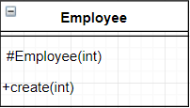

A factory method has been applied to replace the constructor calls. The benefits of this refactoring method include being able to return already created objects instead of creating a new instance, and being able to choose a more descriptive name for the method. For example, in this case the method is named create(), which immediately communicates that the method creates and Employee object.

**Testing**

A unit test can be conducted to check that the object is created and returned as expected. Once the unit test has been completed, a system wide test should be conducted to ensure the code works the same as before it was refactored.